

ENGG1100

Professional Engineering

Semester 1 2023

Saiied Aminossadati

Myrthe Snoeks

**Engagement Portfolio**

Student Name: Samuel Allpass Student Number: 48030504 PBL: 6 Team: Blue

___________________________________________________________________________

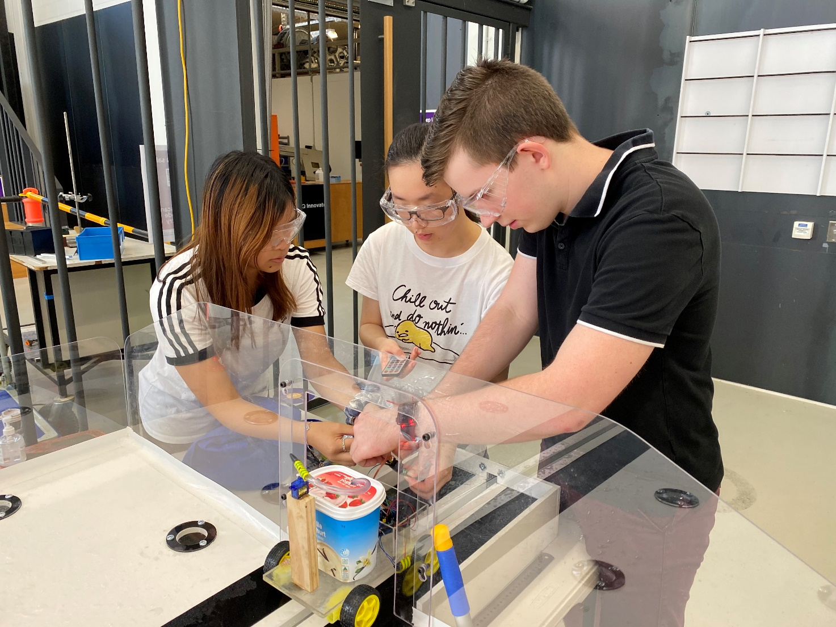

# Table of Contents

Table of Contents i

List of Tables ii

List of Figures iii

1. PBL1 Tasks 1

1.1 Week 1. Introduction to Engineering 1

1.1.1 Week 1-Task 1 1

1.2 Week 2. Project Management 2

1.2.1 Week 2-Task 1 2

1.2.2 Week 2-Task 2 3

1.2.3 Week 2-Task 3 4

1.2.4 Week 2-Task 4 5

1.3 Week 3. Systems Thinking 6

1.3.1 Week 3-Task 1 6

1.3.2 Week 3-Task 2 7

1.3.3 Week 3-Task 3 8

1.4 Week 4. Design Decision Making 9

1.4.1 Week 4-Task 1 9

1.4.2 Week 4-Task 2 10

1.5 Week 5. Materials and Manufacturing 11

1.5.1 Week 5-Task 1 11

1.6 Week 6. Risk Management 12

1.6.1 Week 6-Task 1 12

1.7 Week 7. Sustainable Engineering 13

1.7.1 Week 7-Task 1 13

2. Seminar Reflection 14

2.1 Seminar-Week 2: Structure and Drive Subsystems 14

2.2 Seminar-Week 3: Power and Control Subsystem 15

2.3 Seminar-Week 4: Fluid Delivery Subsystem 16

2.4 Seminar-Week 5: Teamwork and Communication 17

2.5 Seminar-Week 6: Reflective Writing and Storytelling 18

2.6 Seminar-Week 7: Ethical Conduct and Integrity 19

2.7 Seminar-Week 8: Sustainability 20

2.8 Seminar-Week 9: Employability and Professional Practice 21

3. Practical Reflection 22

4. General Reflection 23

# List of Tables

Table 1.1.1: Engineered “things” that affect our lives (Week 1-Task 1) 1

Table 1.2.4: SMART Analysis of Tasks/Activities (Week 2-Task 4) 5

Table 1.3.2: System Level Pairwise Comparison (Week 3-Task 2) 7

Table 1.3.3: Subsystem Level Pairwise Comparison (Week 3-Task 3) 8

Table 1.4.1: Decision Making Matrix (Week 4-Task 1) 9

Table 1.4.2: Sensitivity Analysis (Week 4-Task 2) 10

Table 1.5.1: Costing the Prototype Manufacturing (Week 5-Task 1) 11

Table 1.7.1: Life Cycle Assessment (Week 7-Task 1) 13

Table 2.1: Seminar Reflection - Structure and Drive Subsystems 14

Table 2.2: Seminar Reflection - Power and Control Subsystem 15

Table 2.3: Seminar Reflection - Fluid Delivery Subsystem 16

Table 2.4: Seminar Reflection - Teamwork and Communication 17

Table 2.5: Seminar Reflection - Reflective Writing and Storytelling 18

Table 2.6: Seminar Reflection - Ethical Conduct and Integrity 19

Table 2.7: Seminar Reflection - Sustainability 20

Table 2.8: Seminar Reflection - Employability and Professional Practice 21

Table 3: Practical Reflection 22

Table 4: General Reflection 23

# List of Figures

Figure 1.2.1: Work Breakdown Structure (Week 2-Task 1) 2

Figure 1.2.2: Gantt Chart (Week 2-Task 2) 3

Figure 1.2.3: Modified Gantt Chart with Critical Path (Week 2-Task 3) 4

Figure 1.3.1: Functional Decomposition Layout (Week 3-Task 1) 6

Figure 1.6.1: FMEA for scooter (Week 6-Task 1) 12

# PBL1 Tasks

## 1.1 Week 1. Introduction to Engineering

### 1.1.1 Week 1-Task 1

Discuss with your team and for **two** of the engineered ‘things’ identified in the PADLET, explain how each 'thing' positively and/or negatively impacts our environment/society.

Table 1.1.1: Engineered “things” that affect our lives (Week 1-Task 1)

|  |  |  |
| --- | --- | --- |
| Engineered Things | Positive Impact | Negative impact |
| Bicycle | Reduced global emissions  Decreased requirement for roads and carparks  Increases cyclists fitness | Relatively dangerous mode of transport from cars  Travel distance limited to users fitness |
| Car | Quick and long distance travel possible  Allows for multi-passenger transport  Sheltered structure for safety | Significant contributor to global emissions  High risk transport for all stakeholders; passengers, pedestrians, other cars, etc. |

## 1.2 Week 2. Project Management

### 1.2.1 Week 2-Task 1

Develop the **Work Breakdown Structure** with 3 design objectives and 5 associated tasks/activities for each objective (15 tasks/activities in total).

Figure 1.2.1: Work Breakdown Structure (Week 2-Task 1)

### 1.2.2 Week 2-Task 2

Develop a Gantt Chart.

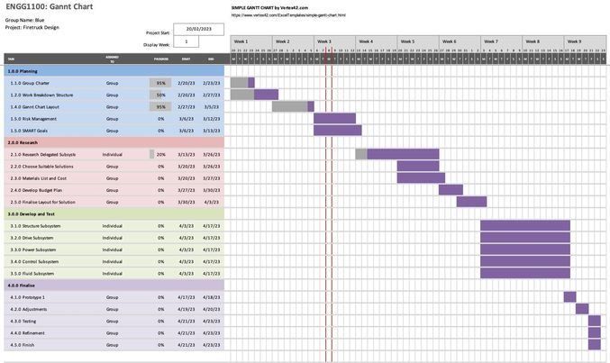

Figure 1.2.2: Gantt Chart (Week 2-Task 2)

### 1.2.3 Week 2-Task 3

Show the connection between tasks/activities on the Gantt Chart and highlight the Critical Path.

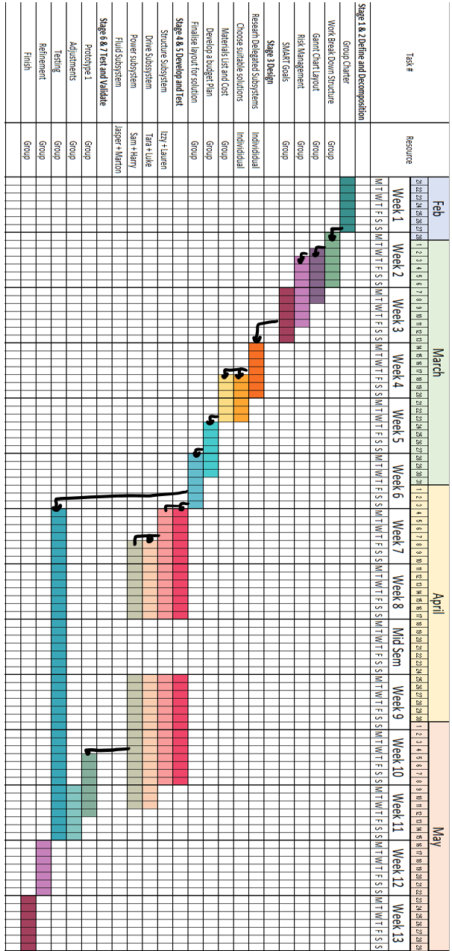



Figure 1.2.3: Modified Gantt Chart with Critical Path (Week 2-Task 3)

### 1.2.4 Week 2-Task 4

Choose 3 out of 15 tasks/activities and make sure they satisfy the SMART goal method. Describe each task/activity with regard to SMART goal.

Table 1.2.4: SMART Analysis of Tasks/Activities (Week 2-Task 4)

|  |  |  |  |
| --- | --- | --- | --- |
| SMART | Task/Activity | Task/Activity | Task/Activity |
| Part summation | Code development | Prototype testing |
| **Specific**  What specifically is the task/activity? | The task is to find and purchase all parts required for all subsystems in the group. | This activity is to create the code for the Arduino to control all parts including the motor wheels, the DC pump, two servo motors and a Bluetooth module. | Testing a fully functional and integrated version of the unmanned fire truck. |
| **Measurable**  How is success measured for the task/activity? | This task can be easily measured using a ‘shopping list’ to ensure all parts are bought. | This task will be measurable by how well it is able to control these components. | Issues in the trucks ability to achieve its set tasks will be indicative of how successful the testing was. |
| **Achievable**  What do you need to complete the task/activity? Is that achievable given your constraints? | The most difficult part of the task is to identify which parts are compatible with each other. However, this task is very achievable using the skills learnt at UQ. | It is very achievable as the internet will be of great assistance. | This is extremely achievable as long as all subsystems are ready for this trial date. |
| **Realistic**  How realistic is achieving the task/activity given the constraints? | It is very realistic given the constraints of $250. | The task is very realistic as it is purely digital and has no risk of being physically impaired. | It is very realistic to be able to test at this time, however, it is unrealistic to claim that we will encounter no issues. |
| **Timely**  What are the timelines for the task/activity? | Two weeks were dedicated for all subsystems to research and decide on the parts used in their respective subsystem. | The task was given three weeks for completion as well as many more given the changing of our fire | The testing is to take place some time in week 11 to ensure two week of modification time was available. |

## 1.3 Week 3. Systems Thinking

### 1.3.1 Week 3-Task 1

For the design of vaccine freezer, develop a Functional Decomposition Layout and identify the subsystems.

Figure 1.3.1: Functional Decomposition Layout (Week 3-Task 1)

### 1.3.2 Week 3-Task 2

Develop the Pairwise Comparison Table for the vaccine freezer (System).

Table 1.3.2: System Level Pairwise Comparison (Week 3-Task 2)

|  |  |  |  |  |  |  |
| --- | --- | --- | --- | --- | --- | --- |
|  | Cooling system (A) | Storage (B) | Casing (C) | Insulation (D) | Sum | Weighting |
| A | - | A | A | A | 3 | 0.5 |
| B | - | - | B | B | 2 | 0.33 |
| C | - | - | - | D | 0 | 0 |
| D | - | - | - | _ | 1 | 0.166 |

### 1.3.3 Week 3-Task 3

Develop the Pairwise Comparison Table for one of the subsystems of the vaccine freezer (Subsystem).

Table 1.3.3: Subsystem Level Pairwise Comparison (Week 3-Task 3)

|  |  |  |  |  |  |  |  |  |
| --- | --- | --- | --- | --- | --- | --- | --- | --- |
| For cooling subsystem | | | | | | | | |
| Criteria | A: Safety | B: Lifespan | C: Performance | D: Weight | E: Cost | F: Environmental Impact | Sum | Weighting |
| A | - | A | A | A | A | A | 5 | 0.33 |
| B | - | - | C | B | B | B | 3 | 0.2 |
| C | - | - | - | C | C | F | 3 | 0.2 |
| D | - | - | - | - | E | D | 1 | 0.06 |
| E | - | - | - | - | - | E | 2 | 0.13 |
| F | - | - | - | - | - | - | 1 | 0.06 |

## 1.4 Week 4. Design Decision Making

### 1.4.1 Week 4-Task 1

Develop a Decision-Making Matrix for one of the subsystems of the vaccine freezer.

Table 1.4.1: Decision Making Matrix (Week 4-Task 1)

### 1.4.2 Week 4-Task 2

To check whether the previous highest total score solution can still easily holds its place, perform a Sensitivity Analysis and re-evaluate the solutions by changing the weighting of a criteria changes by 10%.

Table 1.4.2: Sensitivity Analysis (Week 4-Task 2)

As is evident in table 1.4.2, the adjustment of ±10% to the scaling of each of the six criteria always resulted in the same outcome being that option 2 was the most efficient vaccine freezer.

The lack of variation in the sensitivity analysis indicates that it is appropriate to claim that no further investigation into the power source options was required. This is justifiable as the sensitivity analysis indicates that no single criteria in the decision-making process had an excessive affect on the final outcome.

## 1.5 Week 5. Materials and Manufacturing

### 1.5.1 Week 5-Task 1

Consider the chassis of a robot prototype. Estimate the cost of manufacturing your prototype, based on the manufacturing processes identified earlier. For this activity cost all the:

* Materials,
* Labour, and
* Any out-sourced manufacturing processes identified.

Note: Use the labour cost estimate of $20 per hour, so you'll need to make a timing estimate for manufacture. Try your best at estimating approximate material volumes too. Look back at the Extension Resources in this Pre-Workshop Module for some helpful costing resources. While your project prototype estimate does not include Labour Costs, its part of engineering cost estimating to understand how long something takes to complete, hence try and estimate the time to complete the build.

Discuss with your team and complete this task using the table provided in your portfolio.

Table 1.5.1: Costing the Prototype Manufacturing (Week 5-Task 1)

|  |  |  |
| --- | --- | --- |
| Item | Quantity | Price |
| Jaycar metal chassis | 1 | $59.90 |
| 4m x 80mm screws | 4 | $3 |
| 4m bolts | 12 | $4 |
|  |  |  |
| Sum | | $56.90 |

## 1.6 Week 6. Risk Management

### 1.6.1 Week 6-Task 1

Complete the FMEA for scooter.

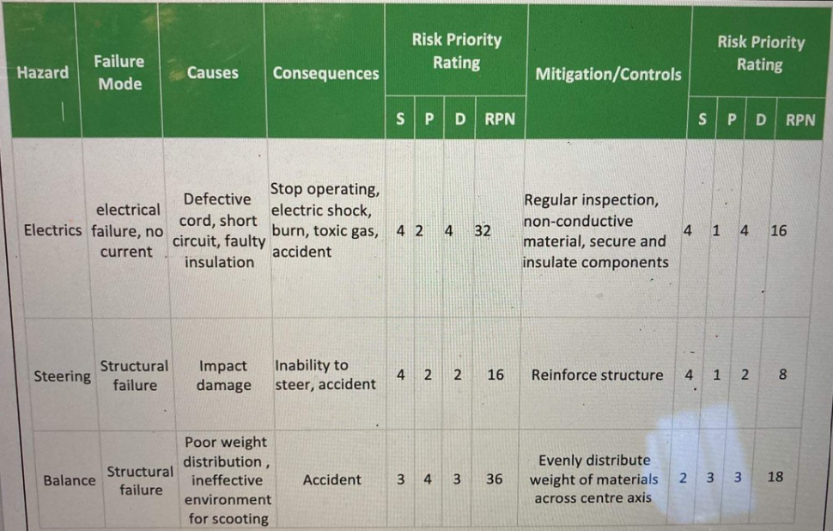

Figure 1.6.1: FMEA for scooter (Week 6-Task 1)

## 1.7 Week 7. Sustainable Engineering

### 1.7.1 Week 7-Task 1

An airline has chosen to utilise a more environmentally friendly option for the in-flight cutlery they provide for inflight meals. The cutlery is made from a bio-plastic composite material (Source: Orthex Group), consisting of:

* 58-63 % bio-PE made of sugarcane ethanol (responsibly produced outside of high-biodiversity areas in Brazil)
* 35-40 % wood fibre from locally grown spruce

Use a Life Cycle Assessment (LCA) to help determine whether the new cutlery is ‘sustainable’.

Table 1.7.1: Life Cycle Assessment (Week 7-Task 1)

|  |  |  |  |  |
| --- | --- | --- | --- | --- |
| **Function Unit (what is the basis for comparison against alternatives?). Utensils for a meal** | | | | |
| **LCA Stage** | **Description** | **Material and/or Energy Inputs and Outputs (Direct)** | **Material and/or Energy Inputs and Outputs (In-direct)** | **Environmental Impact?** |
| 1. **Resources and Raw Materials** ​What are the raw materials – and how are they sourced? | - Sugar from sugarcane (farms)   -Wood from forests (forestry) | CO2, water, nutrients and sunlight. | - Energy for fertilizer, water | Land clearing |
| 1. **Material Processing / Preparation** ​What are the steps to convert the raw material into feed-stock for product production | - Sugar refining, and sugar to ethanol to ethylene  -Wood processing to wood fibres | Chemical energy  Material storage | Energy provided to manufacturing facilities | Land use by industry include: as well as waste products |
| 1. **Product Production** ​How is the product manufactured? | Made by converting sugars in plants to biodegradable plastic through chemical processes. | Chemical energy used in conversion.  Industry is required to mould raw material. | Energy required for facility powering | Energy is used as a catalyst in the process |
| 1. **Distribution** ​How does it get to where it needs to go? | Shipped on mass | Packaging of items and use of machinery to package items. | Fuel required in the shipping of the goods | CO2 emissions |
| 1. **Use** ​What’s involved in its use? | Used as alternative of traditional cutlery | No material, energy inputs or outputs | No material, energy inputs or outputs | Little environmental impat |
| 1. **End of Life** ​Where will these products end up?  Discuss the options – what scenarios are realistic? | Recyclable or in landfill to decompose | Significant energy expenses to recycle | Cost of labour to move/recycle waste | Minimal transmission emissions. Also as they are recyclable they will have minimal environmental effect. |
| **- What are the pros and cons of switching to the bio-based cutlery?** | Pros:   * Environmentally friendlier * No noticeable functionality difference   Cons:   * Slightly higher cost of bio-based cutlery | | | |

# Seminar Reflection

### 2.1 Seminar-Week 2: Structure and Drive Subsystems

Write a reflection that covers the following questions for each seminar:

* What did you learn?
* How do you intend to use the knowledge and experience you gained from this seminar in your project development or professional career?

Table 2.1: Seminar Reflection - Structure and Drive Subsystems

|  |  |  |
| --- | --- | --- |
| Presenter (s) | Organisation | Date |
| Vice Kelly Patrick – UQ Innovate | UQ Innovate | 1/3/23 |
| The first concept discussed in the week 2 seminar was the design process commonly used in engineering projects. Opening the seminar was the concept of system designs, being the overall system, subsystems, components and parts, while also touching on the construction of function means trees. It is these processes that will be utilised in the unmanned firefighting truck in order to organise required tasks in addition to assigning them to particular members. The second concept discussed were the structure and drive subsystems, more specifically that scope, analysis, implementation, verification and maintenance of the subsystems. The seminar clearly demonstrated that the key aspects of investigation in the structure subsystems was the centre of mass, visualised using a free body diagram, additional force factors acting on the body, such as water sloshing, tension, stress and strain, the pros and cons of fasteners and adhesives and finally the reality of building the design. It was recognised that in relation to our project, the longevity, reusability, and feasibility of parts within the unmanned fire truck would prove that fasteners were a more viable option. The final concept, the drive subsystem, discussed the different types of motor, including brushed, brushless, stepper and servo motors. Stressed to the class was the importance of ensuring the motors had enough torque, power, voltage and current for the required load, but it was also announced that whilst data is good, testing is vital. So, the team decided to ensure that the prototype would be completed as quick as possible for excess testing time. | | |

### 2.2 Seminar-Week 3: Power and Control Subsystem

Write a reflection that covers the following questions for each seminar:

* What did you learn?
* How do you intend to use the knowledge and experience you gained from this seminar in your project development or professional career?

Table 2.2: Seminar Reflection - Power and Control Subsystem

|  |  |  |
| --- | --- | --- |
| Presenter (s) | Organisation | Date |
| Richard Yen | School of Electrical Engineering | 8/3/23 |
| Covered in seminar 3 were the power and control subsystems of the unmanned firefighting truck. The purpose of the seminar was to learn about the power requirements and control measures of all integrated subsystems. A detailed description of specifications to acknowledge whilst considering the summation of system parts included, voltage and current requirements, the type and number of batteries used, and how they would all be controlled. It was brought to the attention of the team that all subsystem parts must be DC and that lithium-ion batteries are too hazardous on a small scale to use. In order for the fire truck to be optimised, coordination and communication with other team members is vital such that parts such as the pump which require more current than the controlling Arduino can handle are accounted for. The final topic imparted onto the class was the importance of a structured and efficient code to control all aspects of the UFT. A severe lack of coding knowledge was recognised within the group. Therefore, the seminar informed us that a significant portion of time must be submitted to the production of such a code. In critically thinking about these new teachings, it is recognised that many aspects of these electrical component specifications will be transferable into other components and projects. | | |

### 2.3 Seminar-Week 4: Fluid Delivery Subsystem

Write a reflection that covers the following questions for each seminar:

* What did you learn?
* How do you intend to use the knowledge and experience you gained from this seminar in your project development or professional career?

Table 2.3: Seminar Reflection - Fluid Delivery Subsystem

|  |  |  |
| --- | --- | --- |
| Presenter (s) | Organisation | Date |
| Remo Cossu | Environmental Engineering | 15/3/23 |
| In this seminar, Remo exclaimed the key design aspects and requirements of a fluid delivery system, the purpose of which to reduce the heat from the fire, thus breaking the extinguishing the fire triangle (heat, oxygen, fuel). Remo cleverly used an analogy of a coffee machine, with which he has lots of experience, to demonstrate to the students that the water reservoir, pump, nozzle and water pumps must all be expertly selected in order to act efficiently against factors such as gravity. He achieved this by instructing that the Bernoulli principle, the inverse relationship between fluid velocity and pressure, must be investigated when identifying requirements of the fire truck. Further to this, he outlined the difference between dynamic, and positive displacement pumps, being that a dynamic pump requires being submerged in the water and using centrifugal forces to generate the fluid pressure, while a positive displacement pump utilises reciprocating or rotary motion of its parts to generate pressure without being submerged. He outlined that a cost and energy efficient pump, when partnered with a minimal spray nozzle will make for an effective and quick reduction in the temperature of the fires. It is these key concepts of pumps and nozzles that will be heavily investigated when choosing components for our unmanned fire truck, whilst also being important information into my professional careers. | | |

### 2.4 Seminar-Week 5: Teamwork and Communication

Write a reflection that covers the following questions for each seminar:

* What did you learn?
* How do you intend to use the knowledge and experience you gained from this seminar in your project development or professional career?

Table 2.4: Seminar Reflection - Teamwork and Communication

|  |  |  |
| --- | --- | --- |
| Presenter (s) | Organisation | Date |
| Alexandra Kennedy Clark | Origin | 22/3/23 |
| The purpose of Ms Clarks presentation was to outline how an effective engineering team is constructed and how it has aided her in her professional career. After a detailed introduction about the roles she has held throughout her career, she focused on what is most important to our current positions in ENGG1100, creating a high performing team. She organised the key aspects of a team into 11 points, including but not limited to, having a clear purpose, tracking progress, playing to strength, challenging each other and celebrating accomplishments. In addition to this, she summarised the importance of clear communication within the team, including understanding the audience and purpose, and ensuring appropriate modes of communication were implemented for the job. It is these key points that our team intended to use in our project development in order to ensure all members feel welcome, acknowledged and updated throughout the process. I also have no doubts that such skills and organisational processes will be continued into a professional career in future groups. | | |

### 2.5 Seminar-Week 6: Reflective Writing and Storytelling

Write a reflection that covers the following questions for each seminar:

* What did you learn?
* How do you intend to use the knowledge and experience you gained from this seminar in your project development or professional career?

Table 2.5: Seminar Reflection - Reflective Writing and Storytelling

|  |  |  |
| --- | --- | --- |
| Presenter (s) | Organisation | Date |
| Angela Bushell | UQ Project Governance | 29/3/23 |
| Seminar 6 was run by Angela Bushell and was demonstrated to teach us the importance of understanding and taking advantage of the difference between storytelling and pitching, as well as using the SEAL process to decompose a project, decision, or general situation. SEAL, an acronym for situation, effect, action and learning, is used to organise and understand a given situation for the purpose of making a more informed decision in the next step of the journey. In addition to this structure, Angela identified the difference between storytelling and pitching, being that storytelling is the communication of experienced shaped ideas through many mediums (speaking, writing, etc) in order to move or unite a group, whilst pitching is similar, but the ending/resolution ‘yet to come’. It is clear from this seminar that pitching for licences, patents or other such items is largely a result of oral presentation, to persuade or encourage yourself or your idea to a potential client/buyer/employer. With oral presentations just two weeks post this seminar, the team was clear to devise a strategy of best pitching our prototype to the judges. This led to the action of introducing the SEAL process to both the team’s oral presentation and my individual engagement portfolio. The learnings from this seminar will be maintained into my future career. | | |

### 2.6 Seminar-Week 7: Ethical Conduct and Integrity

Write a reflection that covers the following questions for each seminar:

* What did you learn?
* How do you intend to use the knowledge and experience you gained from this seminar in your project development or professional career?

Table 2.6: Seminar Reflection - Ethical Conduct and Integrity

|  |  |  |
| --- | --- | --- |
| Presenter (s) | Organisation | Date |
| Prof Peter Knights | School of Mechanical and Mining Engineering | 5/4/23 |
| Throughout this seminar, Prof Peter challenged the audience to understand the ethics that are integral to becoming a professional engineer. Peter demonstrated a 4-step code of ethics within engineering, those being, demonstrating integrity, practicing competency, exercising leadership and promoting sustainability. Underpinning this code of ethics are points including but not limited to, being honest, supportive, trustworthy, competent and having an understanding of what the future generations require. Peter then put this code of ethics into practice with real life examples, these being two Boeing 737 Max case studies. After consulting these situations with the code of ethics, it was then decided to understand how these issues occurred (the design flaw, the design solution and safety certification, and then understand the fallout both economically and social that would resultantly occur to the company and around the world. This key exercise will undoubtably be used in my future engineering career whilst also being common task during the process of making the unmanned firefighting truck. In addition to these new skills, Peter also demonstrated that conflicts of interest within our engineering careers are inevitable, such as pitching to previously know audiences, providing rival companies with assistance, hiring previously known people/family members and many more. Although theory is efficient, it is through experience that managing conflicts of interest effectively will become possible in our future careers. | | |

### 2.7 Seminar-Week 8: Sustainability

Write a reflection that covers the following questions for each seminar:

* What did you learn?
* How do you intend to use the knowledge and experience you gained from this seminar in your project development or professional career?

Table 2.7: Seminar Reflection - Sustainability

|  |  |  |
| --- | --- | --- |
| Presenter (s) | Organisation | Date |
| Ted Simmonds |  | 26/4/23 |
| The week 8 seminar reflected on sustainable engineering practices hosted by Ted Simmonds. After a brief introduction to his accomplishments in life so far, Ted identified six main points for sustainable engineering practices guided by the council UK. These practices are as follows, manage risk to minimise adverse impact and maximise benefit to people and the environment, seek multiple views to solve sustainability challenges, contribute to building a sustainable society, present and future Engineering Council UK Guidance on sustainability for the engineering profession, use resources efficiently and effectively, apply professional and responsible judgement and take a leadership role and do more than just comply with legislation and codes: be prepared to challenge the status quo. When challenged to critically think about these points, it was realised that putting such methods into practice, the professionalism with which we conduct our career would not only benefit relationships we potential clients, bosses and team members, but also enable us to stay more organised and clearer surrounding the task at hand. In addition to this, Ted then brought up subjects to keep in mind when considering fire safety, these being detection systems, and extinguishing systems. He challenged us to contemplate which aspects of a potential hazard are within our control, and that which is not, with the example of boundary conditions, what we cannot reach. Subsequently, reflecting on this, it was decided to include safety precautions within our project design, as well as ensuring that power systems are disconnected after use. Undoubtably, these safety regulations and hazardous situation management procedures will be used into my future engineering career. | | |

### 2.8 Seminar-Week 9: Employability and Professional Practice

Write a reflection that covers the following questions for each seminar:

* What did you learn?
* How do you intend to use the knowledge and experience you gained from this seminar in your project development or professional career?

Table 2.8: Seminar Reflection - Employability and Professional Practice

|  |  |  |
| --- | --- | --- |
| Presenter (s) | Organisation | Date |
| EAIT Student Employment team | EAIT Student Employment team | 27/4/23 |
| The final seminar, week 9, hosted the EAIT student employment team. This seminar was presented with the purpose of informing us of both what they can do for us as students, whilst also giving us vital and long-lasting tips on how to present as employable to possible employers. After an introduction to the role of the EAIT team as well as where they can be contacted, the seminar first covered what it means to be employable. They described it as not only having well-developed enterprise skills, but also looking at the time utilisation of the candidate, possible through understanding their co-curricular activities, work experience and research projects. This was then aided through teaching the group the most efficient way to create a resume (CV). The team then highlighted the importance of building connections during university in order to open up and assist in future endeavours. It is from these tips that I will be more aware and eager to take opportunities offered to me in order to build these lasting connections. In addition to this, the presenters began to talk about EEP, the required work experience I must complete to graduate. They highlighted the importance of ensuring that the program I choose for the possible 450 hours of work experience will help build my relationships to further my career in both the short and long term. In critically reflecting on this, being able to understand the value of opportunities presented to me will be a skill built with experience. | | |

# Practical Reflection

Write a meaningful reflection on what you have learned from the mechanical workshop. This should cover the following questions:

• What methods/techniques were discussed?

• What challenges did you face during the session?

• How do you plan to apply any new knowledge/skills to your project?

Table 3: Practical Reflection

|  |  |  |  |
| --- | --- | --- | --- |
| Date | Time | Workshop Supervisor/s | |
| 22/3/23 | 8-10am | Mr Rob Stephan | Mr Grant Tayles |
| This workshop discussed an acrylic shield to protect our Arduino. It taught us how to correctly measure, cut, and drill holes in acrylic in order to fit it to the Arduino. Specifically, these methods and techniques were:   * How to measure using a high accuracy stainless steel digital Caliper. * Etching measurements into acrylic using sharp pointers. * Cutting acrylic with saws. * Drilling into acrylic. * Filing edges of acrylic for a smooth finish.   The main challenge encountered during the session was ensuring the metal pins simulating an Arduino holder were in the correct location. Often during the practical, I was required to widen, or entirely redrill holes in the acrylic in order to fit the pins.  This practical will prove useful in protecting the delicate Arduino within our unmanned fire truck prototype. In addition to this, the new knowledge and skills are transferable to other parts of building the prototype including ensuring drilled holes are accurate, waterproof and safe to touch. | | | |

# General Reflection

Select one of the learning objectives of the course, and state it, then reflect on the following prompts.

* What was your key experience of that objective?
* Give an example of the objective from your experiences of the course. How did it impact you?
* How would you use your experience in your professional career?

Table 4: General Reflection

|  |
| --- |
| A learning objective that I noticed to be most important throughout the course was project management in the form of effective team communication at an engineering standard. Two key examples of communication come to mind, those being communicating with team members, and the oral presentation. Both examples require your communication of engineering ideas to be concise and clear, such that all listening parties understand the thoughts. However, more so with team members, communication goes two ways, such that to be successful, the person must also be willing to listen and engage in the ideas of others. The clearest example of this came when discussing the control system for the unmanned firefighting truck. Myself and Harry, the control subsystem members, had a control method using a PS2 controller, however, as outlined to us by another team member, a simpler and more efficient alternative was possible using a phone app with Bluetooth. If the communication skills, both speaking and listening, of the team were not efficient or up to engineering standards, this idea would not have been implemented and excess work and complexity would have endured. This experience is evidently something to keep in mind going into a professional career, such that in order to communicate with future teams, it is vital that both speaking and listening proficiencies are up to engineering standards. |



Contact details

1. A/Prof Saiied Aminossadati

T +61 7 33653676 E s.aminossadati@uq.edu.au W uq.edu.au

1. CRICOS Provider Number 00025B